**An investigation of the effect of sugar on the rate of respiration of muscle cells. Respiration is the reaction between glucose and oxygen to produce carbon dioxide and water. It is an essential reaction for life as it releases energy for use by the cell. The energy is released in a chemical form as ATP (Adenosine TriPhosphate) molecules.**

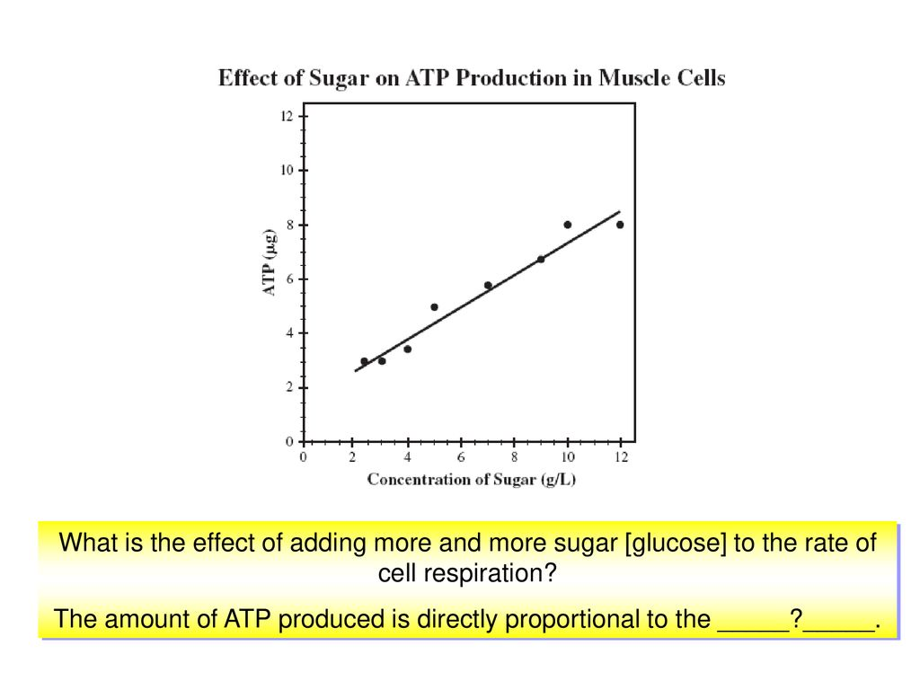

**An investigation of the effect of sugar on the rate of respiration of muscle cells. Respiration is the reaction between glucose and oxygen to produce carbon dioxide and water. It is an essential reaction for life as it releases energy for use by the cell. The energy is released in a chemical form as ATP (Adenosine TriPhosphate) molecules.**

